  - Banco Federal de Finanças
  - North Wind Consulting - Marketing Campaign Analysis
In the three years of your campaign the month of May had the most calls, totalling 12,370 contacts. You lost $2.61 on each of thoes calls. In may you did not hold back at all in your calling and reached out to thousands of people in low conversion groupes that almost always loose money. By contrast in high conversion months you called 1,815 people and made $15.58 per call.
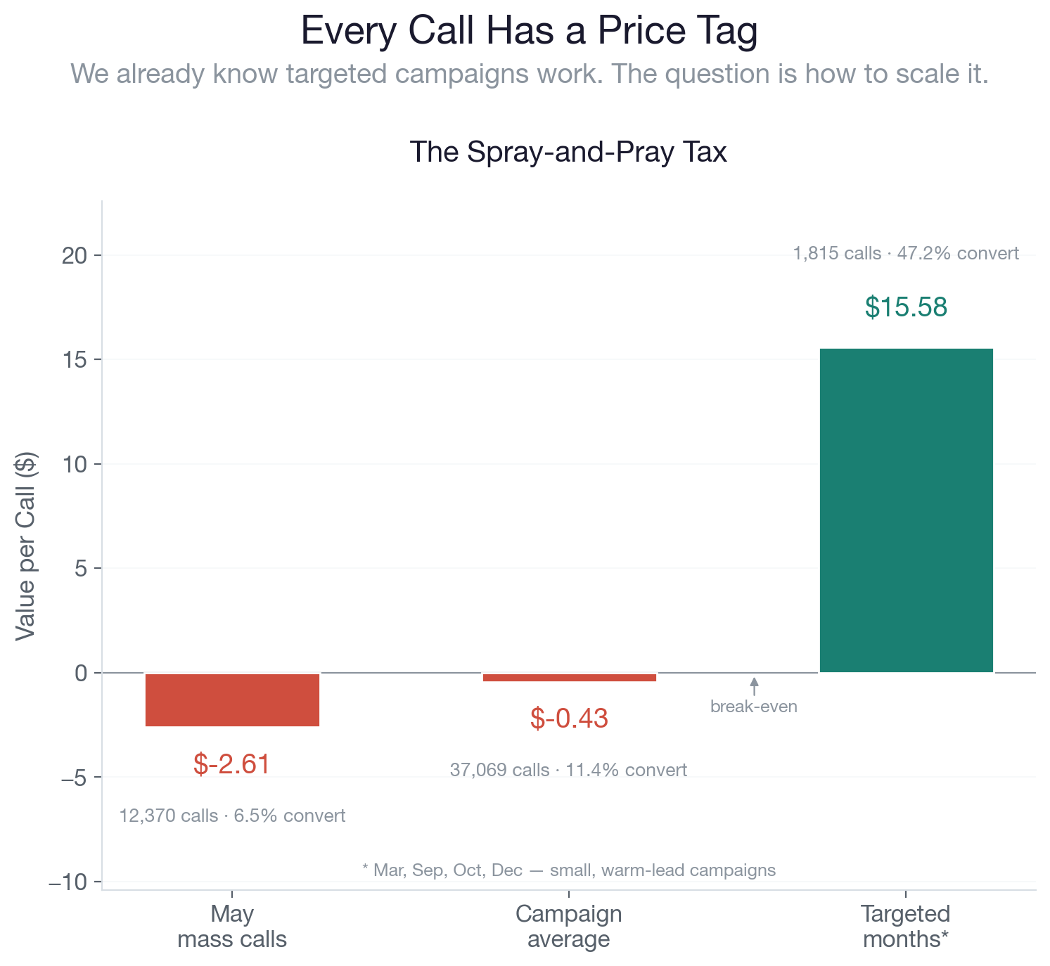
A targeted aproach focased on high value demographics is key, scaling that endevor is the chalenge. Our maching learning (ML) model serves as the bridge between quantity and quality that will allow high value campaigns to be scaled across tens of thousands of high value prospects.
- What we can do for you
We built our model to help you reach consumers who are in need of your services and to help you make money. In a recent tryal campaign you called 410 people and lost $157. Our model would have turned that $157 deficit into a $824 profit.
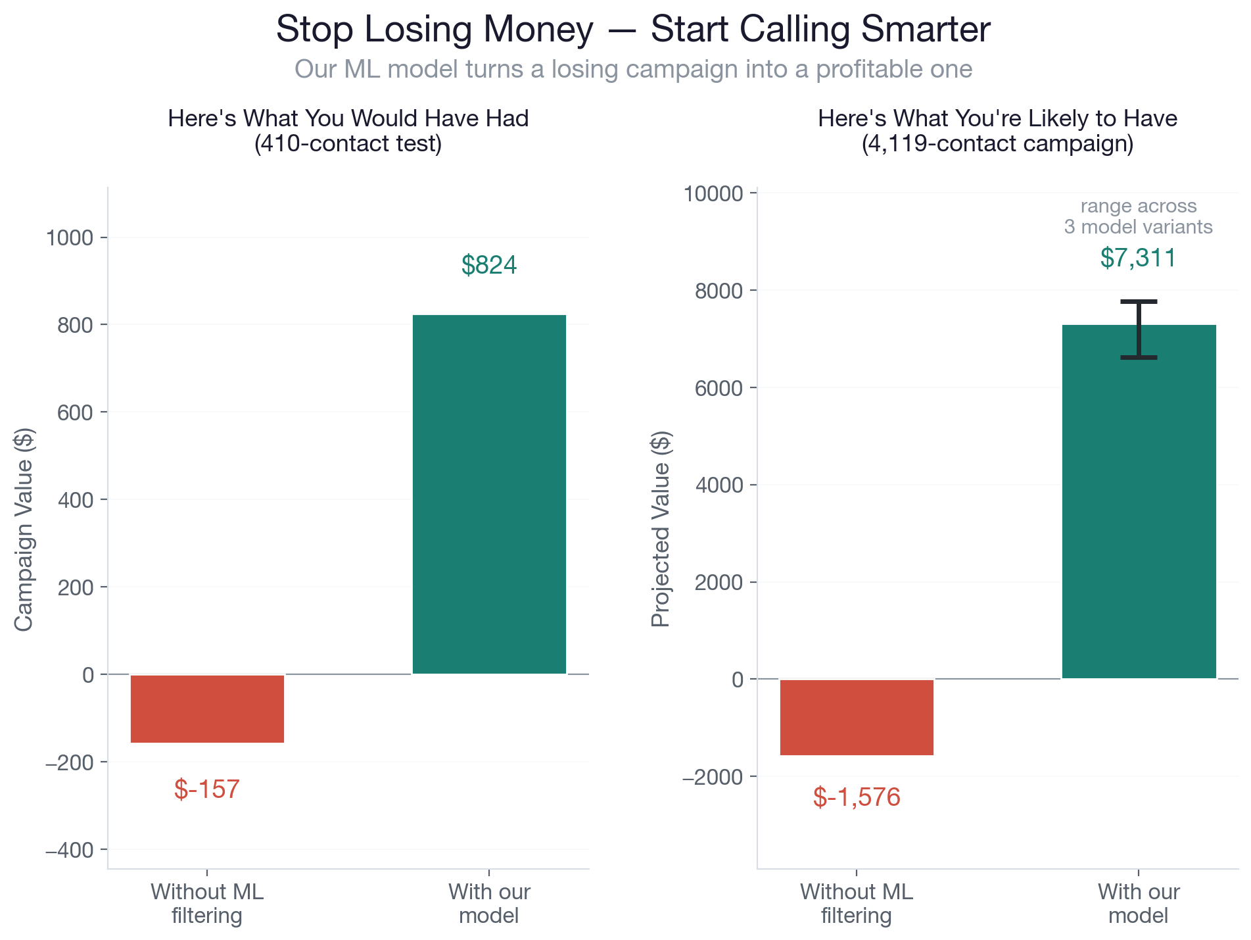
In your next proposed campaign contacting all 4,100 people on your call list will likely lead to a loss of $1,600, we project that once running your call list through out model you will make $7,300 by striping your list down to 480 people.

2. People to call and people not to call
To maximize resource efficiency, our model cleanly separates the database into high-yield priority targets and immediate-skip candidates.
The Golden List focuses entirely on our high-conversion groups. At the very top are previously converted customers, who boast a phenomenal 65.8% conversion rate. Recognizing this massive opportunity, the model shifts this group from a tiny 3% of our historical call list up to 21% of our total outreach.
Similarly, students and retirees exhibit exceptionally strong conversion rates at 31.4% and 25.2% respectively. Retirees are a particularly prime audience; they represent high-liquidity accounts actively looking to lock in reliable term-deposit yields during fluctuating economic climates. To capture this capital, the model scales our retiree outreach from a baseline of just 5% up to 23%.
In stark contrast, The Black List identifies the high-waste groups where our budget goes to die. Customers contacted via traditional landlines (5.3% conversion) and those in blue-collar employment blocks (6.8% conversion) drastically underperform our baseline.
Historically, these two segments clogged our pipeline, consuming a staggering 58% of all marketing calls while returning almost no value. The model aggressively prunes this dead weight, shrinking their combined presence on the call list down to a lean 11% so our team stops wasting time on dead ends.
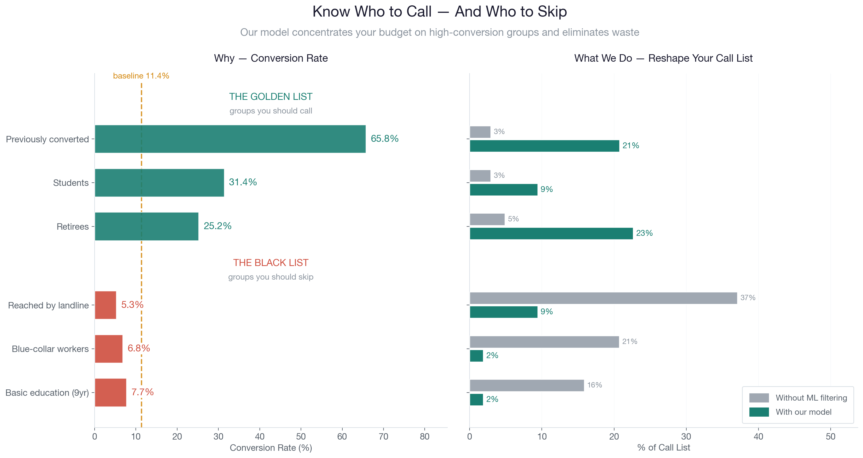

3 – Steps for improvement
The best metric that we currently have to target the value of a costmer is how likely they are to place money in a CD. To project the cost and value of each call we use the average time on a call (30 min) and the average amount of money placed in a CD $4,700. B
Make a github gist and place it here

